**EnVision Math Resources**

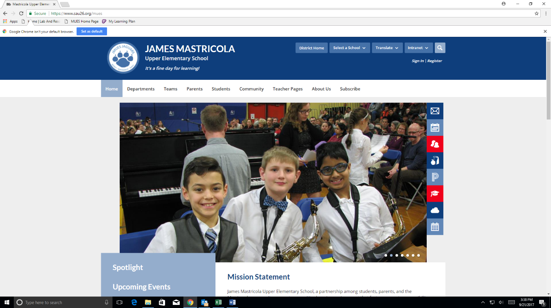**EnVision Math** is a program to help students develop an understanding of math concepts through problem-based instruction, small-group interaction, and visual learning with a focus on reasoning and modeling. Students, parents and teachers have access to content, resources, games, and review assessments. Through EnVision Math, students and parents may log into Pearson Realize in PowerSchool to view student resources. This learning management system gives students instant access to many resources in a single place.

Students and parents may log into EnVision Math Realize at:

[www.sau26.org](http://www.sau26.org) and select Mastricola Upper Elementary School

1. On the right side of MUES webpage, select “P” for **PowerSchool**.
2. Your student username: **firstname.lastname.**

Your password is your school computer password.

1. On the left side select “**Pearson Courses**”.

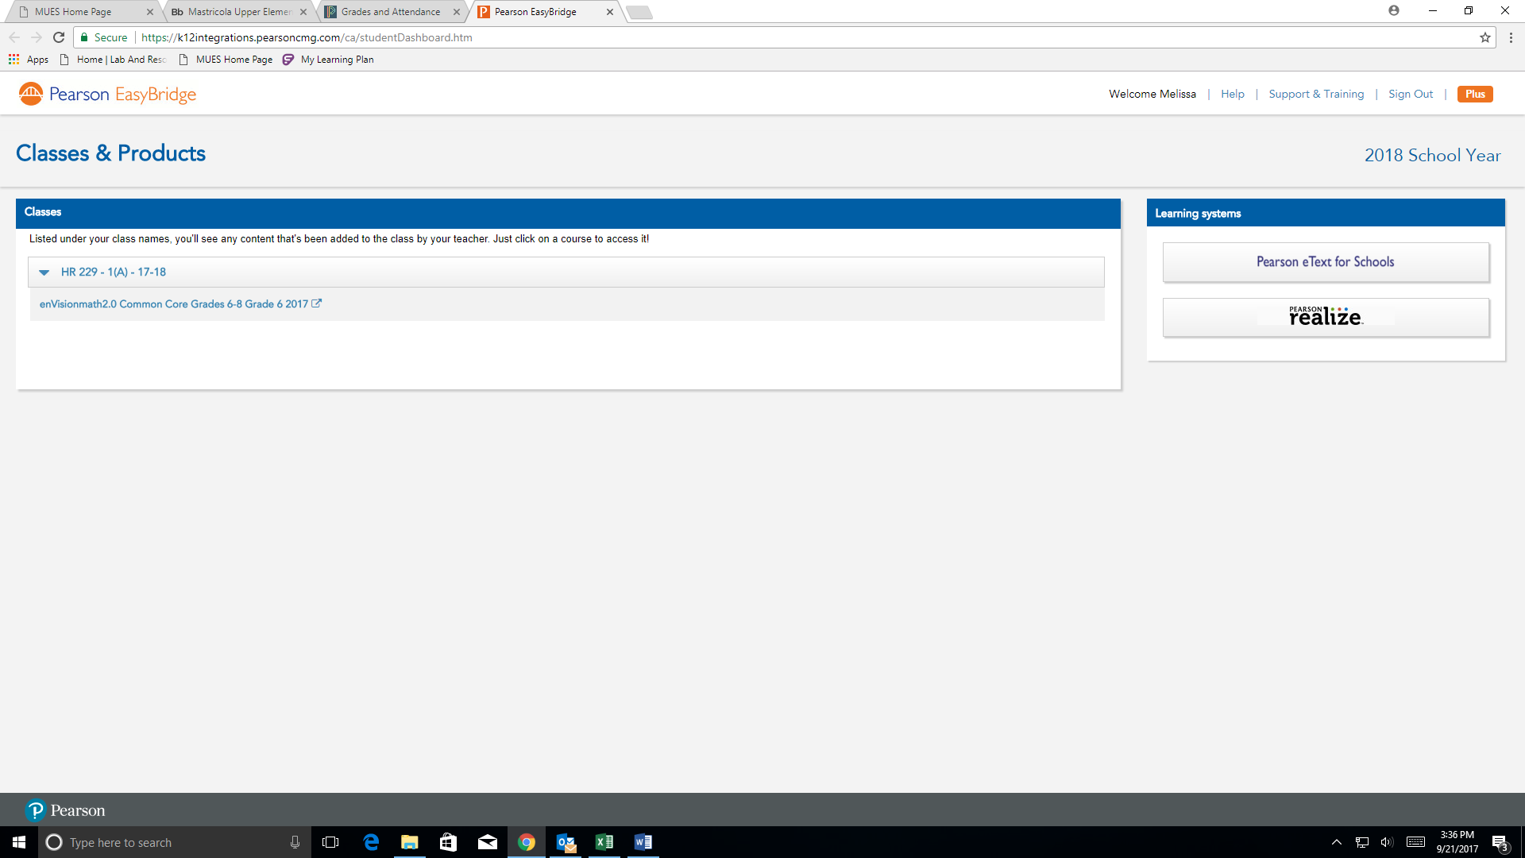

1. Under your homeroom number, select “Envisions Math”.

Under “**Programs**” Select your grade level cover and view “Table of Contents.”

Under “**Classes**”, you will find “eText and Tools, Glossary, Math Tools and Games.”

**Glossary** has a vocabulary list that will read to you as well as offering a visual of many math terms. If you select “Show all Items” you will be able to view a complete vocabulary list.

**Math Tools** has resources available, such as Algebra Tiles, Area Models and Integer Chips to highlight a few.

**Games** has many options with a description of math topics to be practiced.

**Grade Accessible Online Student Edition** with resources.